How to extract tax audit relevant data via

DART (Data Retention Tool)

- Version 4.0 -

Page 1 of 40

Recommendations to the reader

This document is a systematic instruction to extract data from a SAP environment with the SAP data retention tool, DART.

Two SAP professionals - a SAP Basis expert and a functional SAP FI subject matter expert (SME) – should work together in preparing the system environment and defining the settings for the DART engine. The assignment of responsibilities suggested is based on the learnings from the Swedish prototype.

Ideally, the SAP Basis expert owns the following topics ….

INTRODUCTION 5

WHAT IS DART 5

PROJECT – GENERAL OVERVIEW OF THE DART EXTRACTION 6

CONTENTS OF DART DATA EXTRACT 6

1ST STEP – LIMITED DATA VOLUME – JANUARY 2015 8
2ST STEP – WHOLE DATA VOLUME – FISCAL PERIOD 2015 9
SYSTEM REQUIREMENTS 10

DART VERSION INSTALLED 10

AUTHORIZATIONS 12

DART MENU 13

TRX FTWR - DISPLAY SPACE AVAILABLE AND CALCULATE SPACE REQUIRED 15

TRX AL11 – CREATE EXTRACT FOLDER 16

Trx FTWP – Data extraction | Technical settings 20

Trx FTWP – File directories 20

Trx FTWP – File path syntax 21

TRX FTWK – DELETE OBSOLETE DATA EXTRACTS 23

TRX CG3Y – DOWNLOAD DATA EXTRACT FILE 33

RUNTIME ERROR - CX_FS_PATHS_INCOMPATIBLE 34

RUNTIME ERROR - SAPSQL_SQLS_INVALID_CURSOR 38

RUNTIME ERROR – MESSAGE_TYPE_X 39

RUNTIME ERROR – SAPSQL_INVALID_CURSOR 40

Page 2 of 40

…. whereas the SAP FI SME is responsible for the customization of the DART engine, the verification of the extract, the download of the extracted data and the transfer of the data.

INTRODUCTION 5

WHAT IS DART 5

PROJECT ITX – OVERVIEW OF THE DART EXTRACTION 6

CONTENTS OF DART DATA EXTRACT 6

1ST STEP – LIMITED DATA VOLUME – JANUARY 2015 8
2ST STEP – WHOLE DATA VOLUME – FISCAL PERIOD 2015 9
DART MENU 13

DART MENU (TRX FTW0) 13

DART IMPLEMENTATION RECOMMENDATION 14

TRX FTWR - DISPLAY SPACE AVAILABLE AND CALCULATE SPACE REQUIRED 15

TRX FTWSCC – SETTING PER COMPANY CODE 16

TRX FTWP – SETTINGS FOR THE DATA EXTRACT 17

TRX FTWK – DELETE OBSOLETE DATA EXTRACTS 23

TRX FTW1A – EXTRACT DATA 24

TRX AL11 – CHECK FILES CREATED 25

INFORMATION SYSTEM 27

DOWNLOAD/UPLOAD DATA EXTRACT FILE 33

To perform these tasks, it is essential that the necessary authorization objects be assigned to the respective SAP user profiles.

Page 3 of 40

CONTENT
1 | INTRODUCTION ................................................................................................................. |  |  |  | 5
 | 1.1 | WHAT IS DART .............................................................................................................. |  |  | 5
 | 1.2 | PROJECT ITX – GENERAL OVERVIEW OF THE DART EXTRACTION ............................. |  |  | 6
 | 1.3 | PROJECT ITX – STEP BY STEP INSTRUCTIONS .......................................................... |  |  | 6
2 | SYSTEM REQUIREMENTS .............................................................................................. |  |  |  | 10
 | 2.1 | DART VERSION INSTALLED .......................................................................................... |  |  | 10
 | 2.2 | AUTHORIZATIONS ......................................................................................................... |  |  | 12
3 | DART MENU ..................................................................................................................... |  |  |  | 13
 | 3.1 | DART MENU (TRX FTW0) ............................................................................................ |  |  | 13
 | 3.2 | DART IMPLEMENTATION RECOMMENDATION .................................................................. |  |  | 14
 | 3.3 | TRX FTWR - DISPLAY SPACE AVAILABLE AND CALCULATE SPACE REQUIRED .................... |  |  | 15
 | 3.4 | TRX FTWSCC – SETTING PER COMPANY CODE ............................................................. |  |  | 16
 | 3.5 | TRX AL11 – CREATE EXTRACT FOLDER ......................................................................... |  |  | 16
 | 3.6 | TRX FTWP – ENTER SETTINGS FOR THE DATA EXTRACT................................................. |  |  | 17
 | 3.7 | TRX FTWK – DELETE OBSOLETE DATA EXTRACTS ......................................................... |  |  | 23
 | 3.8 | TRX FTW1A – EXTRACT DATA ...................................................................................... |  |  | 24
 | 3.9 | TRX AL11 – CHECK FILES CREATED .............................................................................. |  |  | 25
4 | INFORMATION SYSTEM ................................................................................................. |  |  |  | 27
 | 4.1 | TRX FTWF – DATA EXTRACT BROWSER ........................................................................ |  |  | 27
 | 4.2 | TRX FTWL – DISPLAY | DOWNLOAD EXTRACT LOG ......................................................... |  |  | 28
 | 4.3 | TRX FTWCS – FIELD CATALOG .................................................................................... |  |  | 30
 | 4.4 | TRX FTWH – DATA EXTRACT VIEWS ............................................................................. |  |  | 31
5DOWNLOAD/UPLOAD DATA EXTRACT FILE ................................................................ |  |  |  |  | 33
 | 5.1 | TRX CG3Y – DOWNLOAD DATA EXTRACT FILE ............................................................... |  |  | 33
6 | APPENDIX ........................................................................................................................ |  |  |  | 33
 | 6.1 | ABBREVIATIONS ........................................................................................................... |  |  | 33
 | 6.2 | RUNTIME ERROR - CX_FS_PATHS_INCOMPATIBLE ................................................. |  |  | 34
 | 6.3 | RUNTIME ERROR - SAPSQL_SQLS_INVALID_CURSOR ............................................ |  |  | 38
 | 6.4 | RUNTIME ERROR – MESSAGE_TYPE_X ..................................................................... |  |  | 39
 | 6.5 | RUNTIME ERROR – SAPSQL_INVALID_CURSOR ....................................................... |  |  | 40

Page 4 of 40

1

1.1 What is DART

The Data Retention Tool (DART) helps SAP users to meet the legal requirements concerning data retention and data transfer for tax auditing. DART can be used to extract and store data that is relevant to tax from SAP applications at regular intervals.

DART extracts the data into sequential files and provides tools that you can use to display and evaluate the stored data. The scope of the DART functions takes account of requirements in the area of tax laws in various countries, as well as international requirements.

An example of this is the adjustment of DART to meet the German Principles for Data Access and Verifiability of Digital Documents (GDPdU). Based on the catalog it was determined what kind of data are needed for a government tax audit. It is also possible to include country-specific requirements along with customer requirements into DART. SAP includes generally applicable requirements into the standard version at regular intervals.
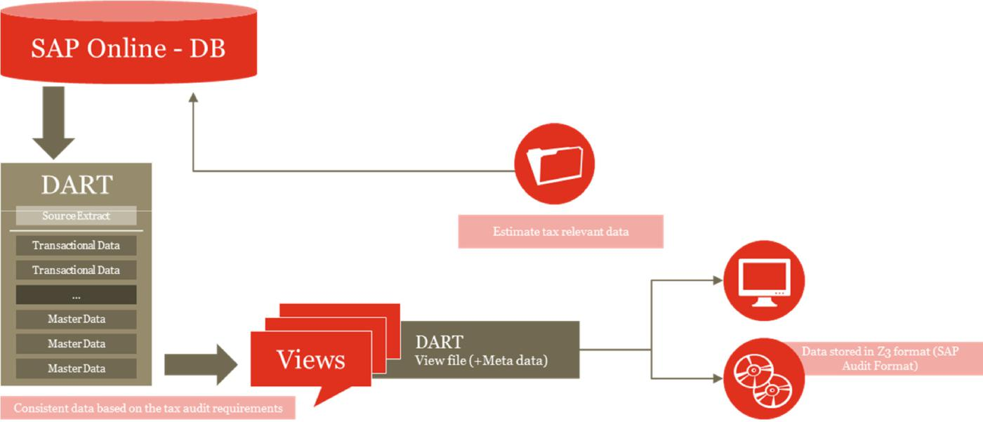

In the context of the project, DART is the standard tool to extract all data relevant to build the SAF-T file matching the OECD requirements.

Page 5 of 40

1.2 Project – General overview of the DART extraction

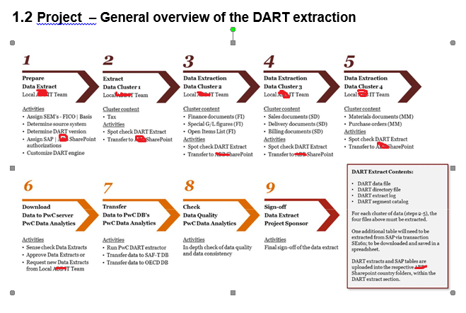

1.3 Project ITX – Step by step instructions

The data, needed for the indirect tax data analysis, is extracted from the relevant SAP system in a two-step approach. This approach allows us to assess/verify with a limited data volume whether or not all relevant tables are extracted before the data for a whole fiscal year is extracted.

In the 1st step, the local IT team is extracting a limited set of data records, January 2015, to test the extraction process. The extracted data is saved on the Sharepoint in the respective country folder. Once the data is available on the Sharepoint folder, the PwC data analytics team will test the data for completeness and accuracy. The PwC data analytics team will sign-off on the data and initiate the 2nd step.

In the 2nd step, the local IT team will extract the data for the entire fiscal period 2015, saved on the Sharepoint in the respective country folder. Subsequently the data will be tested and signed off by the PwC data analytics team.

1.3.1 Contents of DART data extract

The data cluster of the 1st extraction cycle contains data from all areas. The content of the data cluster determines the parameters to be set for transaction FTW1A.

Data Cluster 1 | Tax data

Page 6 of 40

- Finance document (FI)

- Special G/L figures (FI)

- Open Items List (FI)

- Sales documents (SD)

- Delivery documents (SD)

- Billing documents (SD)

- Material documents (MM)

- Purchase orders (MM)

Per DART data extract, the following files have to produced and transferred to the Sharepoint

- DART extract data file

- DART extract directory file

- Data extract log (Trx FTWL)

- Field catalog (Trx FTWCF)

In addition, table TCURF needs to be downloaded via SE16n and saved as MS Excel spreadsheet on the Sharepoint as well.

The 2nd data extraction cycle - for the whole fiscal period 2015 - is segregated into 4 clusters. Per data cluster the parameters for transaction FTW1A have to be set accordingly.

Data Cluster 1 |  | Tax data
Data Cluster 2 |  | Finance document (FI)
 | Special G/L figures (FI)
 | Open Items List (FI)
Data Cluster 3 |  | Sales documents (SD)
 |  | Delivery documents (SD)
 |  | Billing documents (SD)
Data Cluster 4 |  | Material documents (MM)
 |  | Purchase orders (MM)

Page 7 of 40

Per data cluster the following files have to produced and transferred to the XXXX Sharepoint

- DART extract data file

- DART extract directory file

- Data extract log (Trx FTWL)

- Field catalog (Trx FTWCF)

In addition, table TCURF needs to be downloaded via SE16n and saved as MS Excel spreadsheet on the XXXX Sharepoint as well.

1.3.2 1st Step – Limited data volume – January 2015

The local XXXX IT team extracts the data for January 2015, for each company codes agreed and transfers files listed to the XXX Sharepoint.

Data extraction cycle - Step-1

 | Responsible |  |  | Cluster | Activity
 | XXX |  | Local IT team | 1 | Extract |  | Tax data
 | XXXX |  | Local IT team |  | Extract |  | Finance documents (FI)
 |  |  |  |  |  |  | Special G/L figures (FI)
 |  |  |  |  |  |  | Open Items List (FI)
 | XXXX |  | Local IT team |  | Extract |  | Sales documents (SD)
 |  |  |  |  |  |  | Delivery documents (SD)
 |  |  |  |  |  |  | Billing documents (SD)
 | XXXX |  | Local IT team |  | Extract |  | Material documents (MM)
 |  |  |  |  |  |  | Purchase orders (MM)
 | XXXX |  | Local IT team | 1 | Save |  | Data in the respective Sharepoint country
 |  |  |  |  |  |  | folder
 | PwC |  | Data analytics team | 1 | Download |  | Data extract to PwC applications server
 | PwC |  | Data analytics team | 1 | Sense check |  | Sign-off the data extract

Page 8 of 40

1.3.3 2st Step – Whole data volume – Fiscal period 2015

The local XXXX IT team extracts the data for the whole fiscal period 2015, for each company codes agreed and transfers files listed to the XXXX Sharepoint.

The XXXX IT team is extracting the data per company code in 4 clusters for the whole fiscal period 2015.

Data extraction cycle - Step-2

 | Responsible |  |  | Cluster | Activity
 | XXXX |  | Local IT team | 1 | Extract |  | Tax data
 | XXXX |  | Local IT team | 2 | Extract |  | Finance documents (FI)
 |  |  |  |  |  |  | Special G/L figures (FI)
 |  |  |  |  |  |  | Open Items List (FI)
 | XXXX |  | Local IT team | 3 | Extract |  | Sales documents (SD)
 |  |  |  |  |  |  | Delivery documents (SD)
 |  |  |  |  |  |  | Billing documents (SD)
 | XXXX |  | Local IT team | 4 | Extract |  | Material documents (MM)
 |  |  |  |  |  |  | Purchase orders (MM)
 | XXXX |  | Local IT team |  | SE16n |  | Download table TCURF
 | XXXX |  | Data analytics team | 1-4 | Save |  | Data in the respective Sharepoint country
 |  |  |  |  |  |  | folder
 | PwC |  | Data analytics team | 1-4 | Download |  | Data extract to PwC applications server
 | PwC |  | Data analytics team | 1-4 | Sense check |  | Data extracts
 | PWC |  | Data analytics team | 1-4 | Execute |  | PwC DART extractor
 | PWC |  | Data analytics team | 1-4 | Transfer |  | Data to SAF-T DB
 | PWC |  | Data analytics team | 1-4 | Transfer |  | Data to OECD DB
 | PWC |  | Data analytics team | 1-4 | In depth check |  | Data extracts
 | PWC |  | Data analytics team | 1-4 | Status |  | To project management and local XXXX team

Page 9 of 40

2 System Requirements

2.1 DART Version installed

DART is a cross application sub-component CA-GTF-DRT. To validate the DART version installed, please proceed as described below.

Call transaction SE11 | Enter “DART1” as search criterion into the field “Type Group”
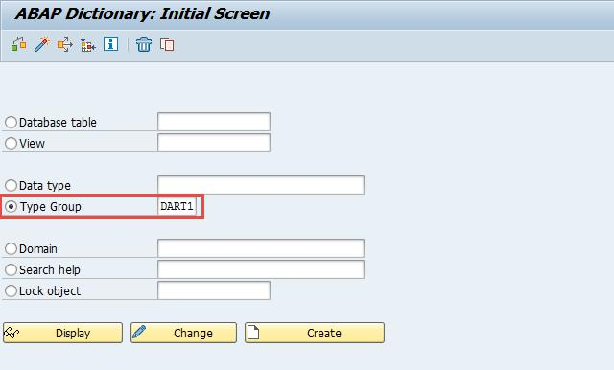

Click on the DISPLAY button …

Page 10 of 40

… to see the DART release implemented
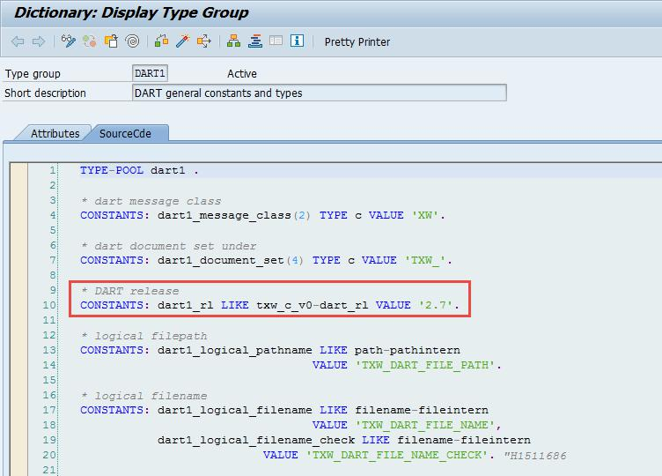

Whether version 2.7 or 2.7e is implemented is not shown. It depends on the EHP implemented.

The present manual is based on the DART version 2.7 or later. If the current DART version in your system needs an upgrade, please refer to the SAP notes listed below

491141 Dart Version 2.0

622095 Dart Version 2.1

668943 Dart Version 2.2

702511 Dart Version 2.3 for ECC 5.00

810014 Dart Version 2.4

105084 Dart Version 2.5 (Version is contained in all releases > ERP 2005) 1173540 Dart Version 2.6 (Version is contained in all releases > ERP 2005 EP 3 1419580 Dart Version 2.6e (Version is contained in all releases > ERP 2005 EP 4) 1511234 Dart Version 2.7 (Version is contained in all releases > ERP 2005 EP 5) (1993990 Dart Version 2.7e) (Version is contained in all releases > ECC 6.00 EP 8) (2239757 Dart Version 2.8) (Version is contained in all releases > ECC 7.3)

Page 11 of 40

2.2 Authorizations

An overview of all DART transactions and the associated authorization objects (including authorizations for Basis transactions) can be reviewed via transaction SU22 | Package FTW1. Enter transaction SU22 in the command field, add the selection criteria and hit the ENTER key.
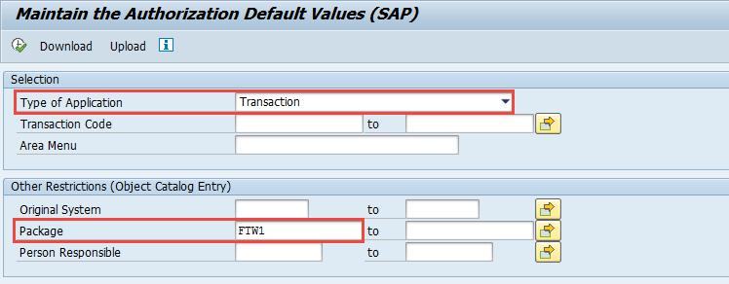

To display all authorization objects assigned to a transaction code, click on the respective transaction code.
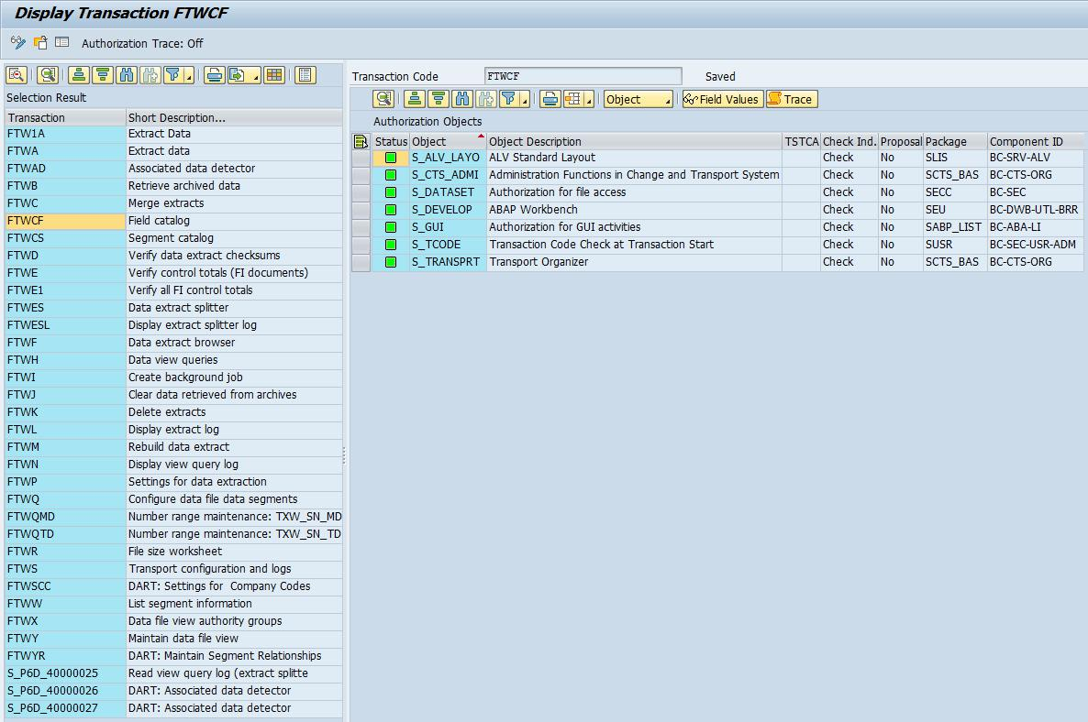

User profiles might need to be amended, depending on the tasks assigned to a staff member. How user profiles are amended and assigned depends on the GRC concept (Governance, risk and compliance) in place.

Apart from DART specific authorization objects, a SAP user with access rights to transaction AL11. CG3Y and FILE is required.

Page 12 of 40

3 DART menu

3.1 DART menu (Trx FTW0)

Access the DART menu by entering the transaction code FTW0 into the command field or use the menu path shown below
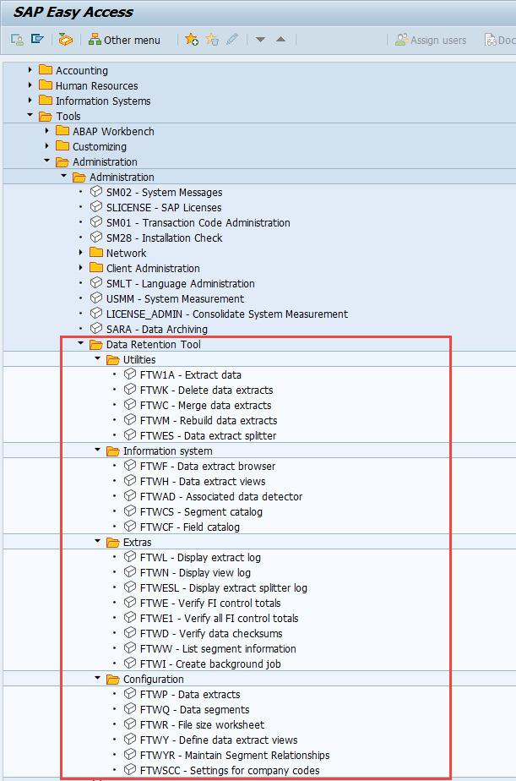

Page 13 of 40

3.2 DART Implementation recommendation

Only “Configuration” settings are transported from the development system to the production system environment. All other activities - e.g. entering the selection criteria for the data extract - are performed directly in the target environment.

Program – parameters are entered in target environment

Customizing – settings are transported
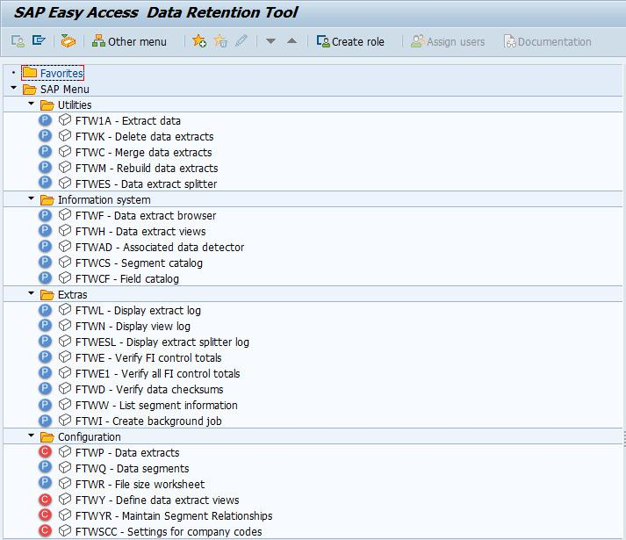

Page 14 of 40

3.3 Trx FTWR - Display space available and calculate space required

The data extracts are saved as a separate data set on the SAP application server. To prevent the data extraction program to failing - due to insufficient space available - it is advisable to calculate the space needed before the extraction program is executed. Historical data extracts should be deleted via transaction FTWK to free up space (see chapter 3.7 below)
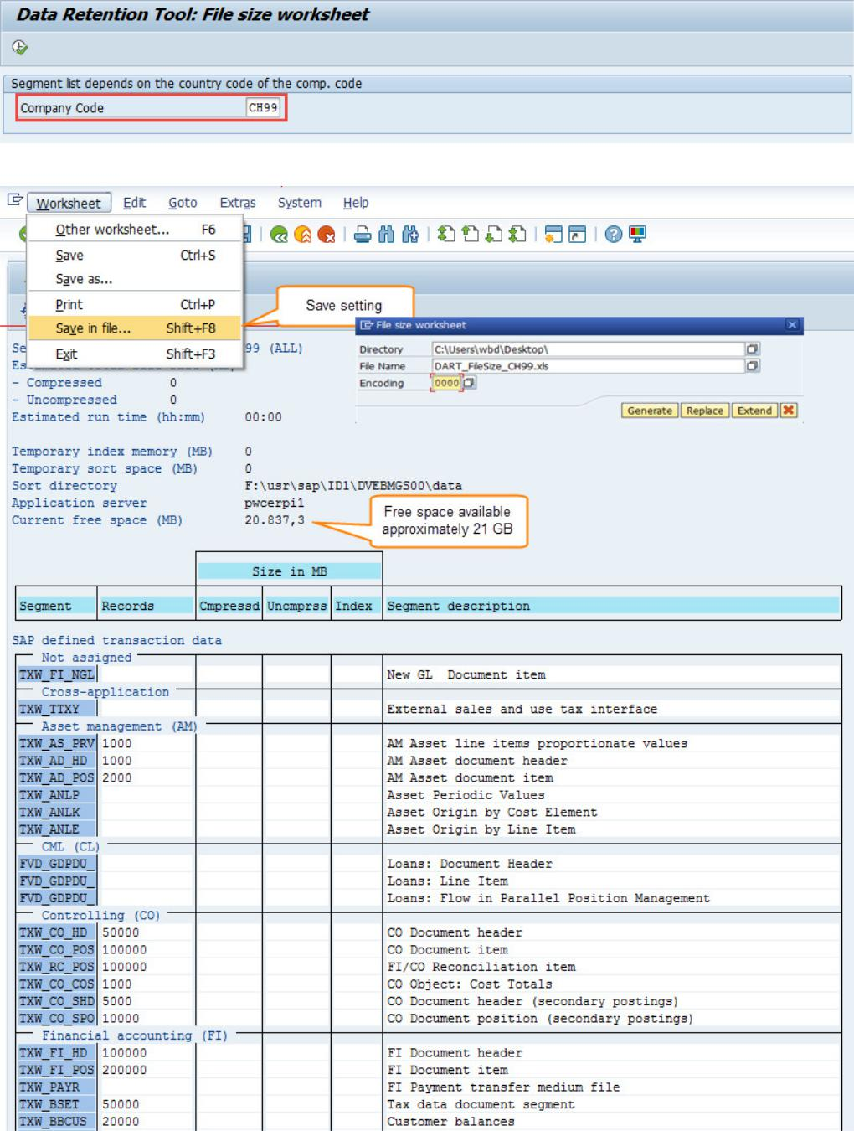

Based on number of records per area entered, the system calculates the need for space.

Page 15 of 40

A summary is issued.
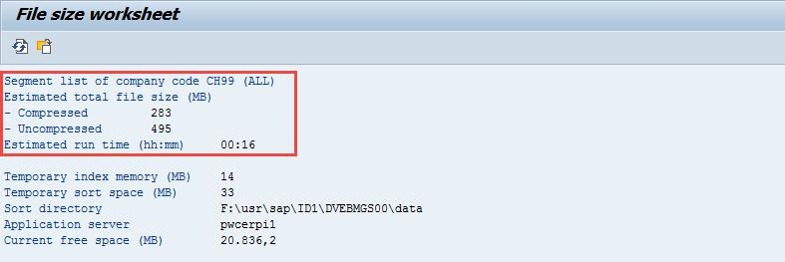

3.4 Trx FTWSCC – Setting per company code

Per company code, it needs to be decided whether or not only the fields …

- relevant for the US only = (5 Segments | 138 Fields) + (common area = 170 Segments | 2’132 Fields) or

- relevant to DE only = (245 Segments | 3’621 Fields) + (common area = 170 Segments | 2’132 Fields) or

- ALL Fields = 420 Segments | 5’891 Fields

… are selected.
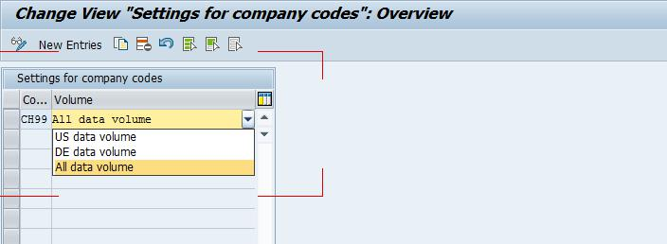

For the XXX ITX project, all data fields need to be selected with the parameter “All data volume”.

3.5 Trx AL11 – Create extract folder
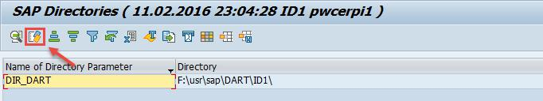

To create a new entry for a directory, click on the “Configure” button ….

Page 16 of 40

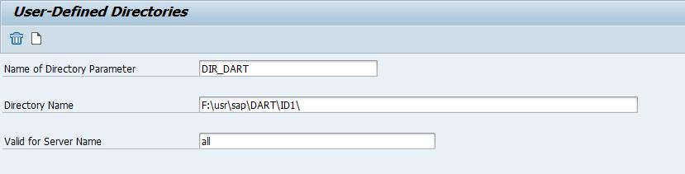

… and enter all credentials. Save the entry. This entry is needed in step 3.6.6

- Trx FTWP – Enter settings for the data extract

  - Trx FTWP – Enable change mode

In order to enter data, enable the change mode
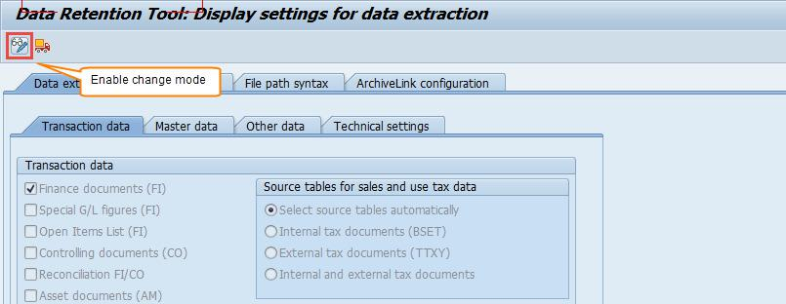

Page 17 of 40

3.6.2 Trx FTWP – Data extraction | Transactional data

For the extraction, only data relevant for indirect tax are included in the selection. Data pertaining e.g. to internal accounting (Controlling) are not relevant for the XXX
ITX project.
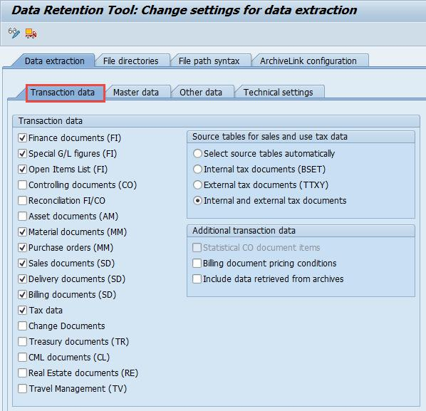

3.6.3 Trx FTWP – Data extraction | Master data
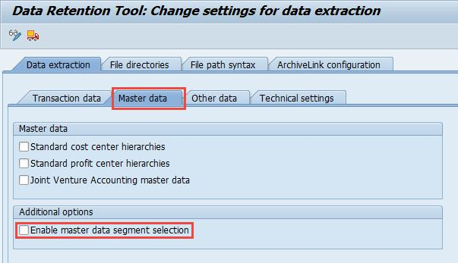

Page 18 of 40

The flags in section tab “Master data” are not ticked since Controlling data is not relevant for the project.

In the section, “Additional options” the flag “Enable master data segment selection” is not ticked. The flag enables the selection of individual master data on the selection screen of transaction FTW1A. For the XXX ITX project, it is not necessary to select master data individually.

3.6.4 Trx FTWP – Data extraction | Other data
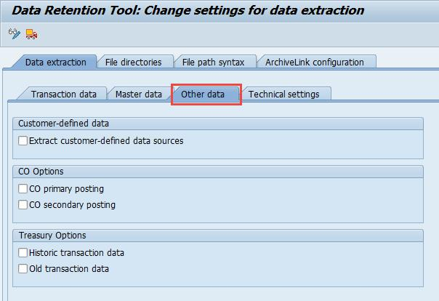

No additional selections needed.

Page 19 of 40

3.6.5 Trx FTWP – Data extraction | Technical settings
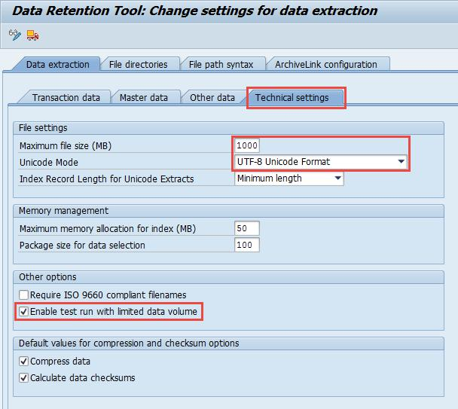

Enter the parameters in the section “File settings” as indicated in the screen shot. In the section, “Other options” tick the flag “Enable test run with limited data volume”. Therefore, the field - “Maximum number of documents” - is displayed on the selection screen of the Extract program – see chapter 3.8 below. For the XXXX ITX project, the flag needs to be ticked to be able to perform test runs, with a reduced number of data records.

In the section “Default values for compression and checksum options” tick the flags “Compress data” and “Calculate data checksums”

- Trx FTWP – File directories

The file directory created on the application server needs to be referenced in this step. Enter the symbolic directory set name and a description.
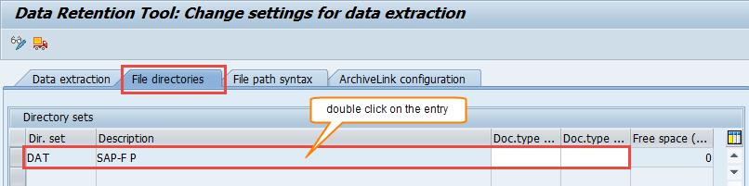

Page 20 of 40

Click on the entry to enter the physical path name on the next screen.
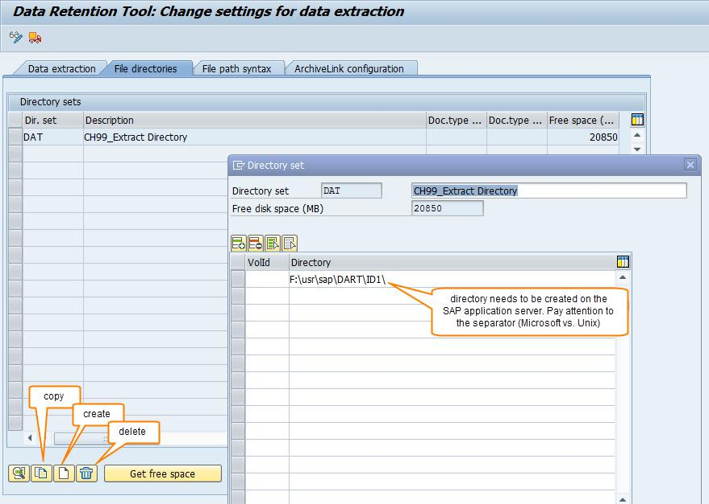

3.6.7 Trx FTWP – File path syntax

Enter the parameters for the physical file path.
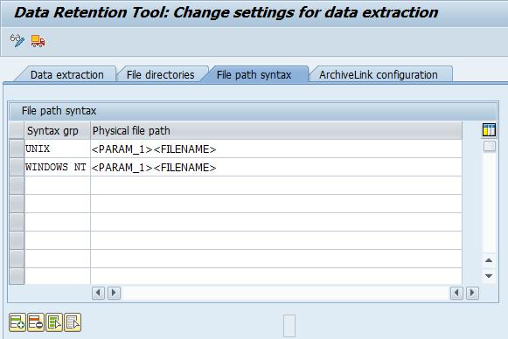

Page 21 of 40

3.6.8 FTWP – ArchiveLink configuration

No entries are necessary on the “ArchiveLink configuration” tab.
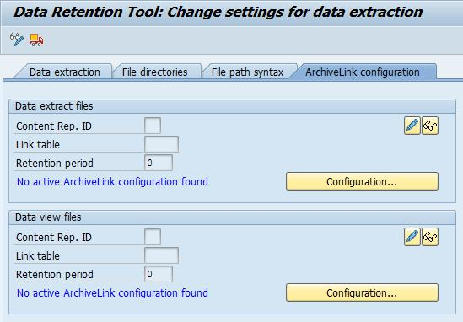

After the last step is performed, save the settings and create a transport request.
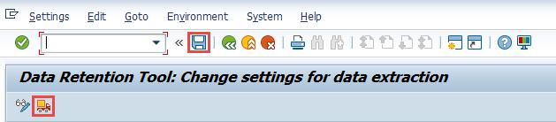

Page 22 of 40

3.7 Trx FTWK – Delete obsolete data extracts

Before a new data extract cycle is started, check whether obsolete historical data sets need to be deleted. When transaction FTWK is executed, the following pop-up window is displayed.

Click on the file that needs to be deleted. A confirmation pop-up window is displayed
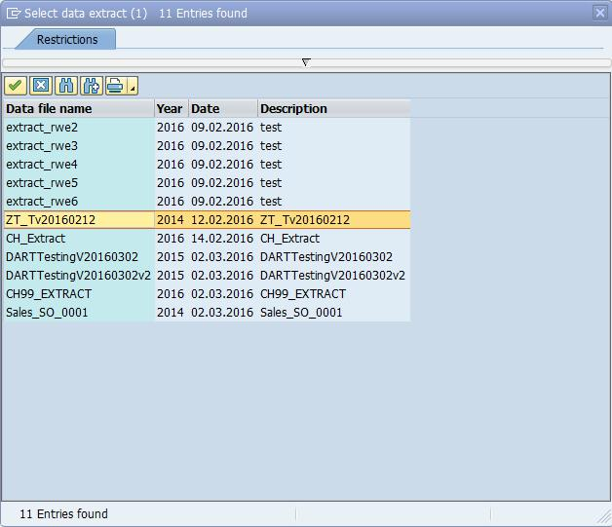

An additional pop-up window is shown that needs to be confirmed.
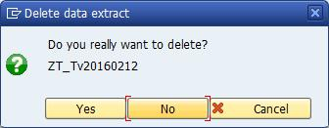

When confirmed, a pop-up window asks for the directory set associated with the data file.
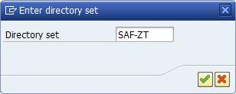

Page 23 of 40

When confirmed, the “Directory set” needs, associated with the file, needs to be chosen (refer to 3.6.6 above).
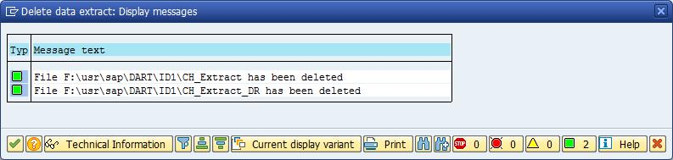

3.8 Trx FTW1A – Extract data
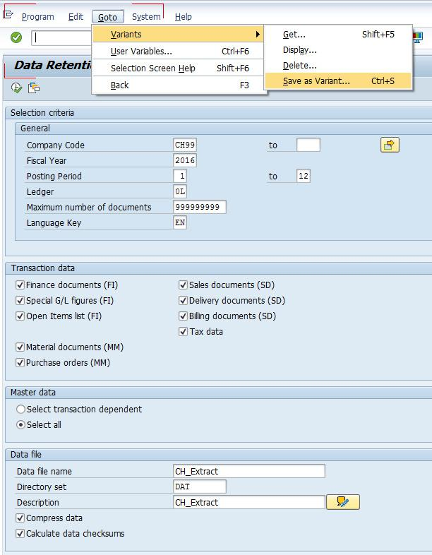

On the selection screen, only the fields are shown that were activated in chapter 3.6. Enter the necessary parameters in the data extract screen.

Page 24 of 40

It is recommended to save the settings as a variant to be able to run the program with the same selection criteria again. Due to the data volume, all DART extracts should be run in the background to prevent time-out.
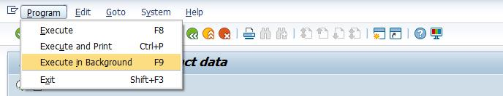

After the program ends, a summary is issued that can be viewed via the information system. For further details, please refer to chapter 4 below.

3.9 Trx AL11 – Check Files created
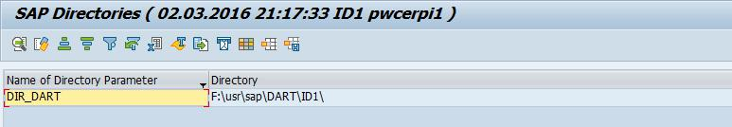

Double click on the

Directory Parameter

As an example, please see below the directory on the application server and the files created by DART, based on the settings shown in this document.

For each DART data extract, two files are created. A data file and a directory file. The directory file is identified with the suffix “filename_DR”. The directory file contains system information that is needed if a data file is uploaded to an SAP application server.

For the XXX ITX project, only the data file needs to be down loaded and transferred.

Page 25 of 40

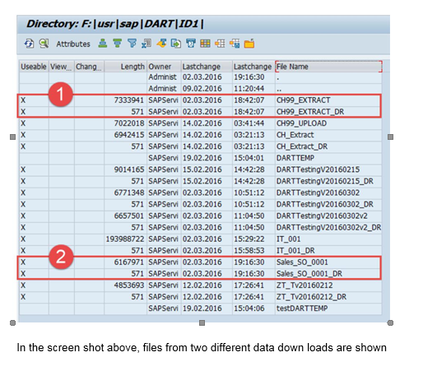

These files were created based on the parameters shown in this documentation

 These files are used to show the options available to analyze data with the information system in the chapter 4 below.

Page 26 of 40

4 Information system

Before transferring a data file to the PwC data analysis team, the data extracted needs to be verified. In a first step, the summary of the data extract is reviewed. If need be, spot checks on specific tables can be performed. The purpose of the validation is the check completeness but not the content of the data files.

4.1 Trx FTWF – Data extract browser

To display the extract summary, enter the “Data file name” …
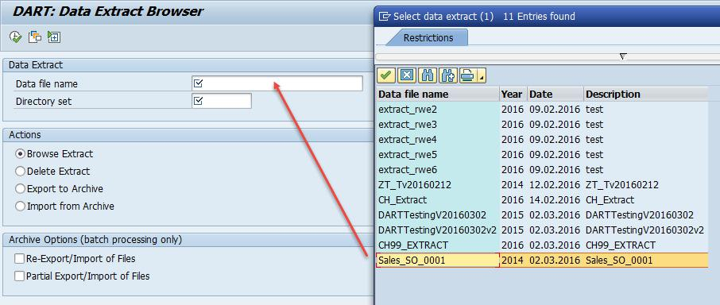

… and the symbolic “Directory set” name in the respective entry fields.
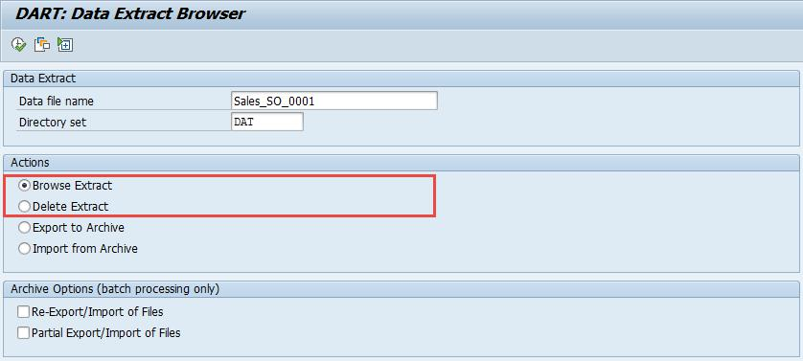

Page 27 of 40

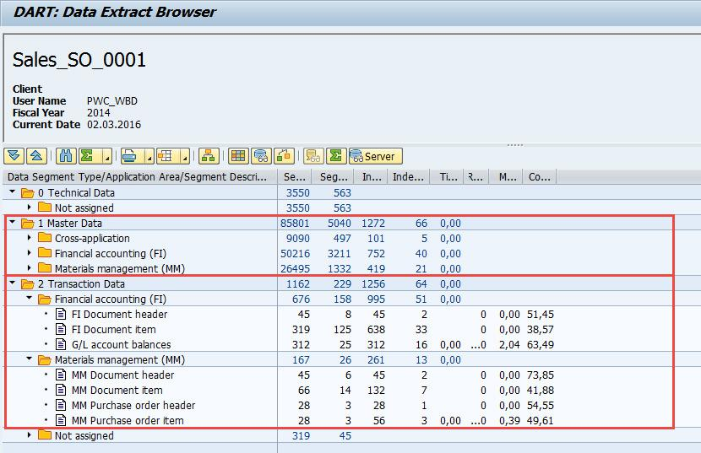

The summary gives an overview of the data extracted and the number of records extracted. If no data was extracted - e.g. for master data – the respective folder is missing.

4.2 Trx FTWL – Display | Download extract log

Transaction FTWL is showing the parameters used for the extracting the data with transaction FTW1A
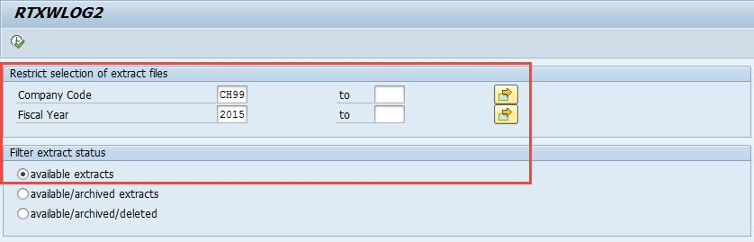

Confirm the selection parameters by hitting the ENTER key.
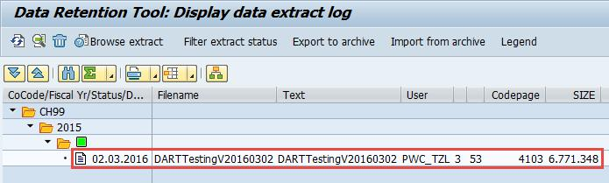

Double click on the extract you would like to have the log displayed.

Page 28 of 40

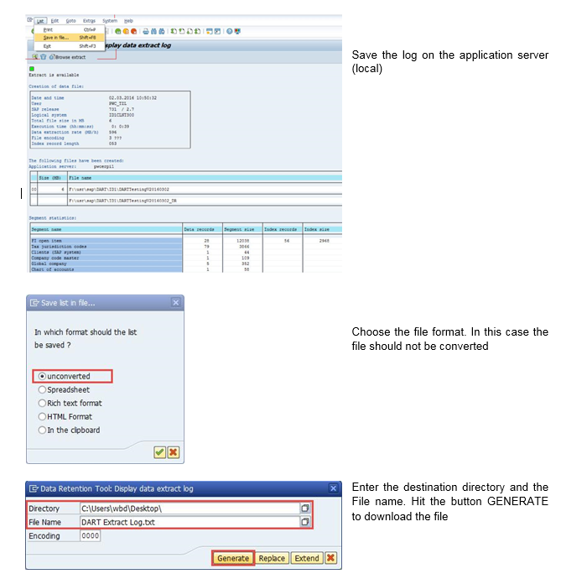

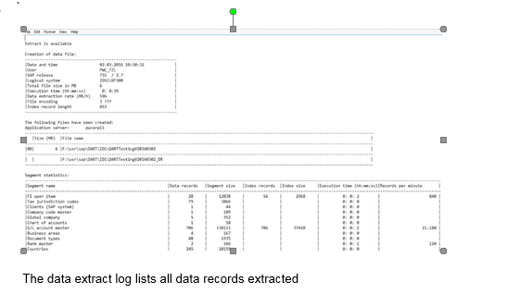

4.3 Trx FTWCF – Field catalog

The field catalog shows the mapping of SAP tables to DART segments. Only a selected number of fields are assigned to a DART segment. Data of one or many SAP tables can be assigned to a DART segment.
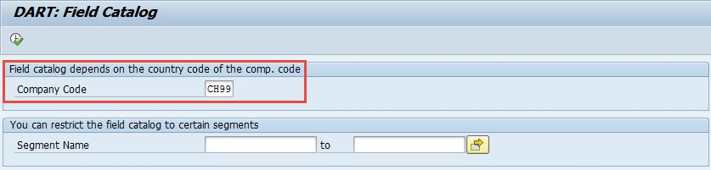

Enter the company code and execute the report
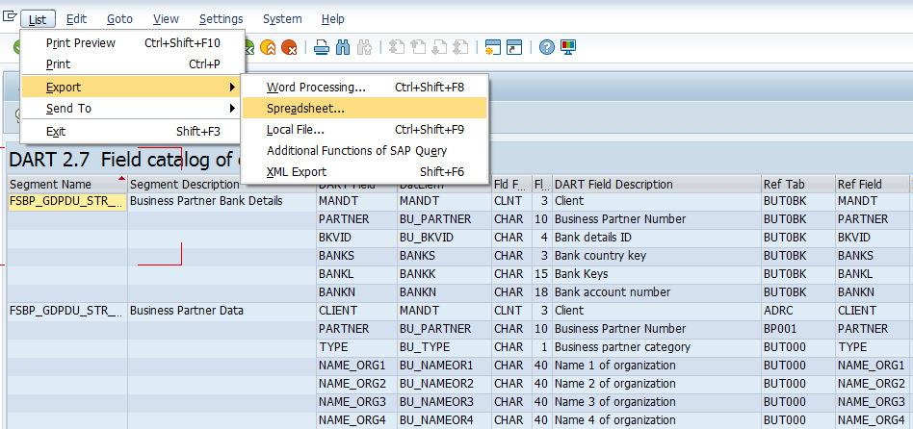

Save the log on the application server (local) as an MS Excel spreadsheet.
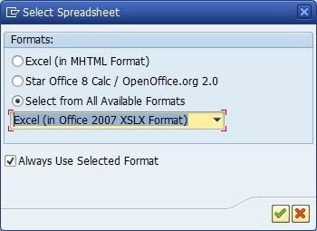

Page 30 of 40

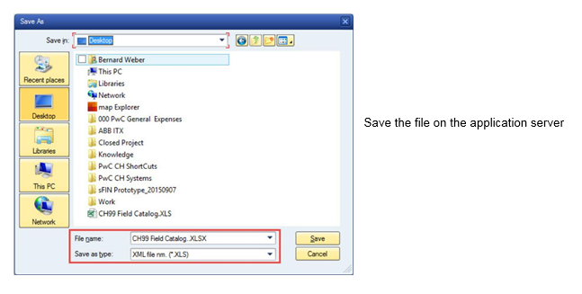
4.4 Trx FTWH – Data extract views

The extracted data can be checked with standard reports. In the example below, the query for purchase order headers is executed

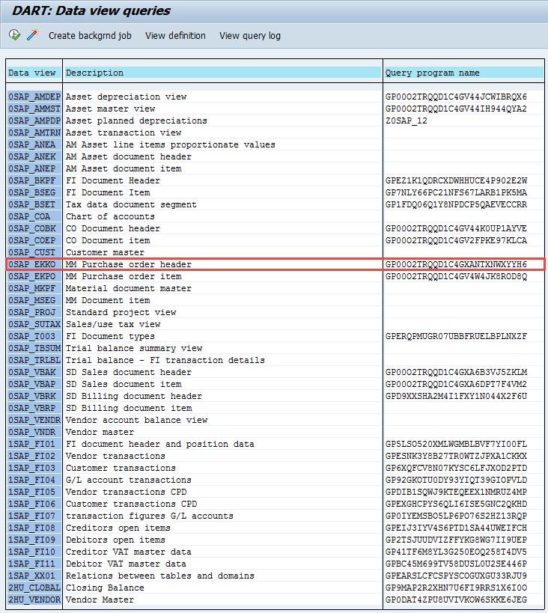

Double click on the query to be executed. The selection screen of the query is displayed.

Page 31 of 40

Fill in the key fields in the section “Source Extract” and hit the EXECUTE button.
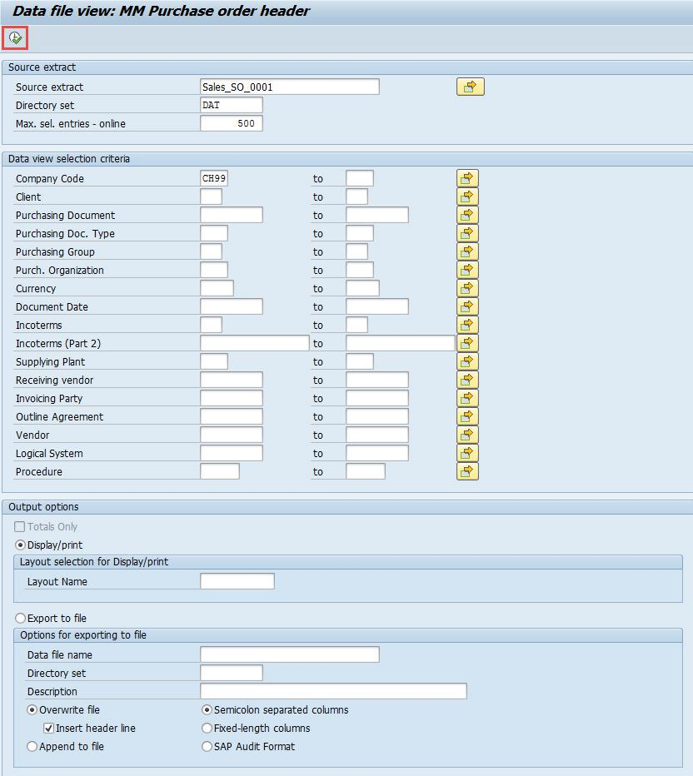

Use the ALV viewer options to change the display layout.
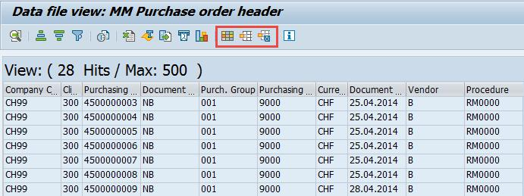

Page 32 of 40

5 Download/Upload data extract file

5.1 Trx CG3Y – Download data extract file

Download the extract to your front end (Laptop)
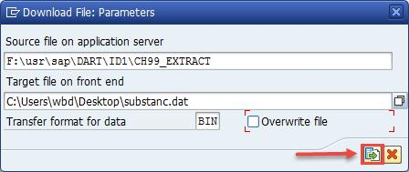

After the successful data download, a confirmation message is displayed.

6 Appendix

6.1 Abbreviations

 | Abbreviation | Long Text | Description
 | DART | Data retention tool | n/a
 | Trx | SAP transaction code to be entered in the command field

Page 33 of 40

6.2 Runtime Error - CX_FS_PATHS_INCOMPATIBLE

When the data entry for transaction FTWA1 is confirmed–(see chapter 3.8 above) the data exception below may be generated.
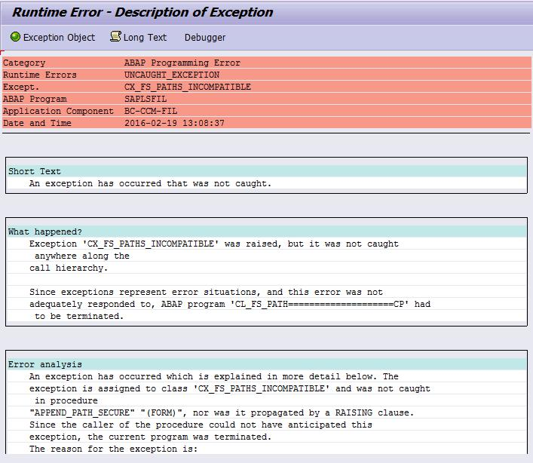

Recommendation

Use the search term "CX_FS_PATHS_INCOMPATIBLE" to see all notes regarding this exception.

Depending on the release and/or support package you either can apply a note (Solution-1) or you have to define logical path instead of a physical one (Solution-2).

6.2.1 Solution-1 – Apply SAP note

Implement SAP note 2243652 through SNOTE or upgrading to corresponding support package.

Page 34 of 40

6.2.2 Solution-2 - Define logical path and file name

Please be aware that the following instructions – the entry format – are specific to an UNIX environment.

Logical file names can be defined as client specific – Trx SF01 – or cross-client – Trx FILE. A client specific definition ALWAYS overrides a cross-client definition. Therefore, ensure that in every client, any unnecessary client specific definitions are deleted.

6.2.2.1 Define logical PATH name – Trx FILE
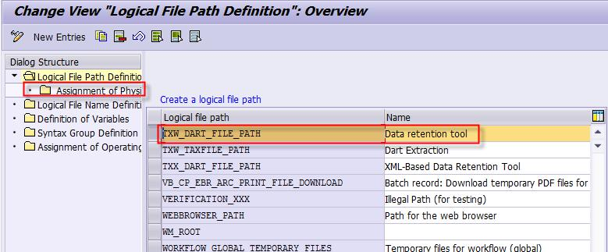

In this particular case, an existing template entry was used.
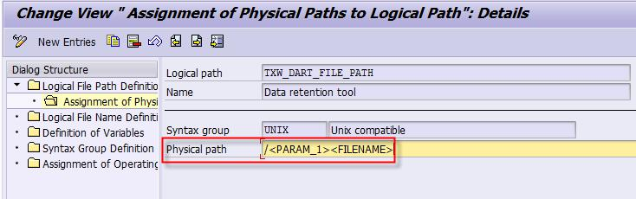

To be flexible, parameters are entered, instead of logical name.

The physical path is the path where the file is saved on the application server. When assigning file names, the symbol <FILENAME> must be added at the end. This symbol is replaced at runtime with the physical file (or path) name. No part of the physical file name in the path name must be defined.

6.2.2.2 Define logical FILE name – Trx FILE

In this particular case, an existing template entry instead of a new entry is used.
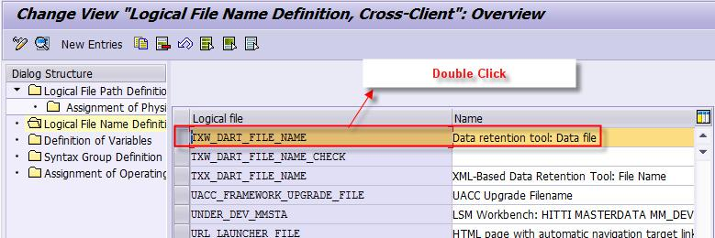

In this particular case, an existing template is used. If needed, a new entry can be created.

Page 35 of 40

When the file is created in the application server, it will have the name that was entered in the field “Physical file”. In our case, a parameter is substituting the file name. The parameter <PARAM_2> is referenced in transaction FTWA1 - chapter 3.6.7 above.
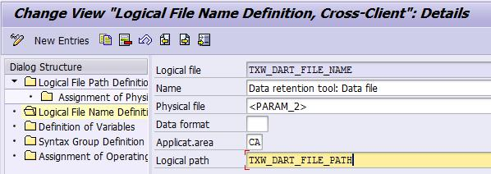

Enter the application area in the field “Applicat.area”.

The following application areas are available

Application Area | Short Description
XF | Non-application-dependent from Financial Accounting view
AM | Asset Accounting
BC | SAP NetWeaver
CO | Controlling
FI | Financial Accounting
GL | General Ledger
HR | Human Resources
IS | Industry Solutions
MC | Logistics Controlling
MM | Materials Management
OC | Office & Communication
PM | Plant Maintenance
PP | Production planning
PS | Project System
QM | Quality Management
SD | Sales and Distribution
EC | Enterprise Controlling
TR | Treasury
CA | General cross-application
CR | Customer Relationship Management (CRM)
BW | Business Information Warehouse (BW)
EB | EBP (Enterprise Buyer Professional)

Specify the data format whether it is ASC or Binary.
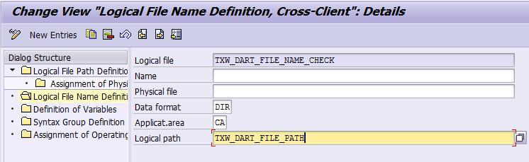

Page 36 of 40


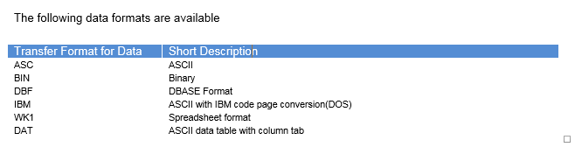

6.2.2.3 Define file directory

In this step the file directory is defined – see chapter 3.6.6 above
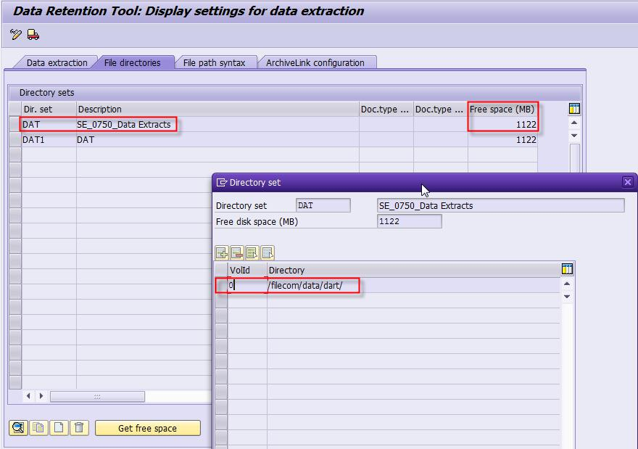

Go to the “File directories” tab and enter the Directory path.
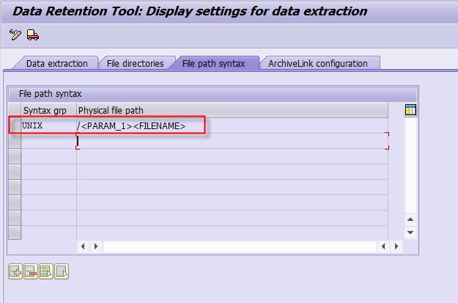

Go to the “File path syntax” tab and enter the parameters

Page 37 of 40

6.2.2.4 Define directory set name

When running the data extract transaction FTW1A again (see chapter 3.8 above) enter the “Data file” name defined in chapter 3.6.6 above
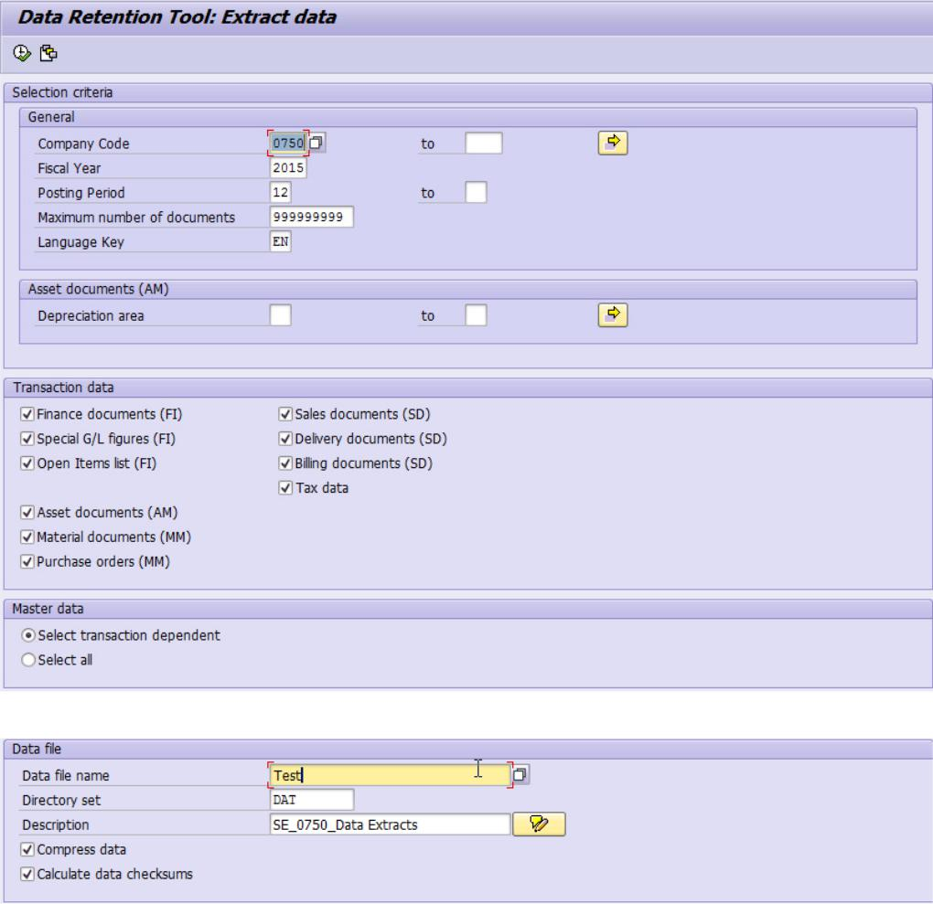

Enter the “Directory set” name and description of the file

6.3 Runtime Error - SAPSQL_SQLS_INVALID_CURSOR

When material units are extracted by transaction code FTW1A, a runtime error with the message SAPSQL_SQLS_INVALID_CURSOR is encountered.

Implement SAP note 2085587 through SNOTE or upgrading to corresponding support package.

Page 38 of 40

6.4 Runtime Error – MESSAGE_TYPE_X
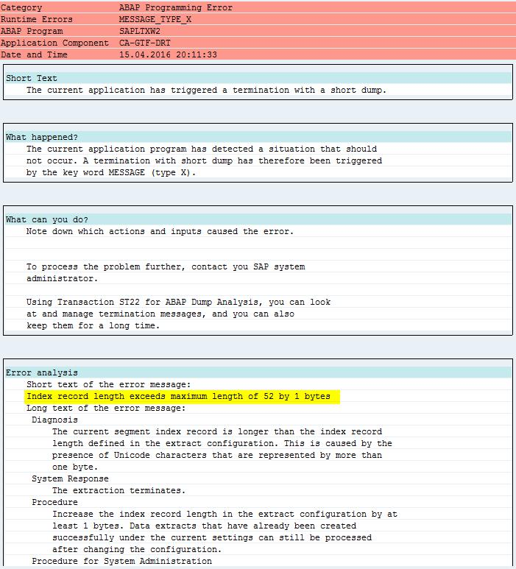

Change the parameters in transaction NFTWP as follows
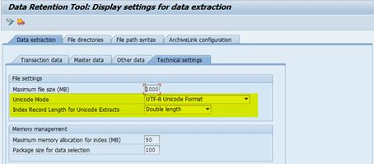

Page 39 of 40

6.5 Runtime Error – SAPSQL_INVALID_CURSOR
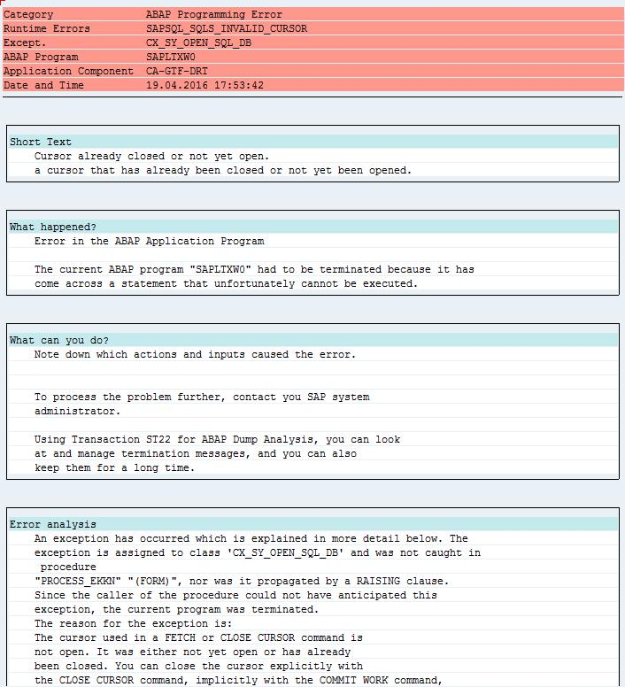

Implement SAP note 2104718 and 2085587 through SNOTE or upgrading to corresponding support package.

Page 40 of 40

